UNIVERSITY WEST, TROLLHÄTTAN
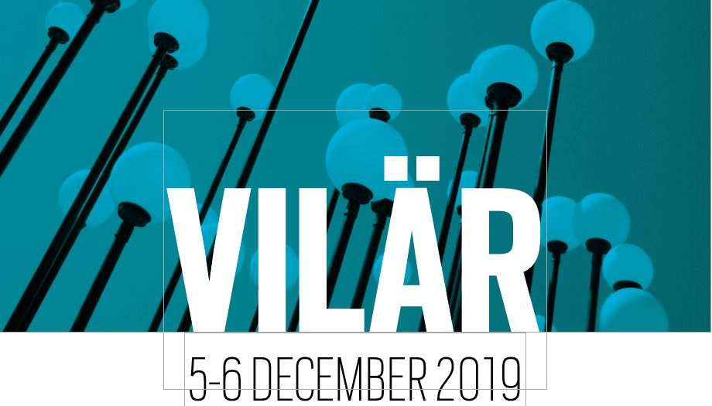

SESSIONS

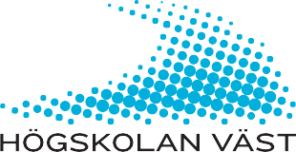

Thursday, December 5th
12.00 - 13.30 Registration with lunch
13.30 - 14:45 Key Note: Professor Denise Jackson
15.00 - 15.30 Parallel Sessions I
15.30 - 16.00 Coffebreak
16.00 - 16.30 Parallel Sessions II
16.30 - 17.30 Networking and mingle at Posters
FREE TIME
19.00 Dinner and Entertainment!

Friday, December 6th

8.30 - 8.45 Welcome to day 2
8.45 - 10.00 Key Note: Professor Lorna Unwin
10.00- 10.30 Coffebreak
10.30 -11.00 Parallel Sessions III
11.15 -11.45 Parallel Sessions IV
12.00 -12.30 Parallel Sessions V
12.30 -13.15 Lunch
13.15- 14.30 Key Note: Docent Mario Romera Vega
14.30 Coffe to stay or to go
ROOM – J111

Thursday, December 5th

Parallel sessions
Chair: Monika Hattinger, University West
15.00–15.30 (P, Swedish)
Gruppsamtal som stöd för pedagogers lärande – En studie genomförd vid sex förskolor
Camilla Seitl, University West

16.00–16.30 (P, Swedish)
Går det att bli erfaren Snabbare?
Anders Sandblad, Combitech/University West

16.30–17.30
Networking and mingle at Posters (H102)

Friday, December 6th

Parallel sessions
Chair: Kristina Johansson, University West

10.30 -11.00 (P, English)
Knowledge and Negotiation. Theoretical Observations in Relation to the Development of a Master Program in Work Integrated Political Studies and Beyond

Fredrik Sunnemark, University West

10.30–11.00 (I, Swedish)
Practical Mixing of Virtual and Real

Daniel Sjölie, University West

12.00–12.30 (P, English)
The Policy of University-Industry Relationships in Sweden
Sepideh Nikounejad, University of Gothenburg

ROOM – J105

Thursday, December 5th

Parallel sessions
Chair: Karin Sjögren, University West
15.00–15.30 (P, English)
What Competence is Not

Charlotte Arghavan Shahlaei, University West, Ulrika Lundh Snis, University West

16.00-16:30 (P, English)

Producing digital stories for language learning and digital competence across generations and positions of learners in municipalities
Kristina Brocker, Martin Dalenius; Strömstad Municipality; Maria Spante, University West

16.30–17.30
Networking and mingle at Posters (H102)

Friday, December 6th

Parallel sessions
Chair: Per Assmo University West
10.30 -11.00 (P, English)
Toward Hybrid Spaces for Immersive Experiences of Work-integrated Learning: An Initial Inquiry
Amir Haj-Bolouri, Ville Björk; University West

11:15–11.45
Participants Perspectives and Results from Competence Development Courses for Industrial Work Integrated Learning
Kristina Eriksson, Monika Hattinger; University West

12.00–12.30 (Close Reading, English)
Research Design for Learning in WIL
Lennarth Bernhardsson, Mikael Andersson; University West

ROOM – J103

Thursday, December 5th

Parallel sessions
Chair: Lars Svensson, University West

15.00–15.30 (P, Swedish)
Att bädda för ny kunskap
Sarah Samuelsson, Region Västra Götaland/University West

16.00–16.30 (P, Swedish)
Kompetensutveckling för kunskapsförsörjning inom skola och utbildning
Erika Karlsson, Wilma Lundqvist Westin, Per Assmo; University West
16.30–17.30 Networking and mingle at Posters (H102)

Friday, December 6th

Parallel sessions
Chair: Per-Olof Thång University of Gothenburg
10.30 -11.00 (P, Swedish)
Rektorer, lärande och digitalisering
Thomas Winman, Ingemar Johansson; University West
11:15–11.45 (P, English)
Propper Planning and Preparation Prevents Piss Poor Performance (7P) -Training for The Fictive Scenario or Learning to Deal with Reality?

Martin Schüler, Kristina Johansson, Josefa Vega Matuszczyk; University West
12.00–12.30 (P, Swedish)
Att skapa samsyn kring kriterier för god undervisning
Pernilla Holmstedt, Linda Björk Andersson; Kristianstad University

ROOM – J113

Thursday, December 5th

Parallel sessions
Chair: Kristina Eriksson, University West

15.00–15.30 (P, English)
Kritiska föreställningar och reflektioner om robotar och artificiell intelligens i svensk skola: när lärarnas programmeringskunskaper spelar roll
Ana Fuentes Martinez, Sara Ekström, University West

16.00–16.30 (P, English)
The mastery of assembly work
Masood Rangraz, University West
16.30–17.30 Networking and mingle at Posters (H102)

Friday, December 6th

Parallel sessions
Chair: Kristina Sandström University West
10.30 -11.00 (I, English)
A Novel Blended Learning Course Developed Jointly Between Three Universities to Address Competence Development of Professionals in Digitalized Manufacturing
Kristina Eriksson, University West, Koteshwar Chirumalla Mälardalen University, Mikael Ericsson University West, Lars Håkansson Linnaeus University

11:15–11.45 (P, English)
Telling stories from the sea: Boundary work and face-saving strategies in maritime post-simulation debriefing
Charlotte Sellberg, University of Gothenburg Astrid Camilla Wiig, University of South-Eastern Norway
12.00–12.30 (P, English)
Transforming surface learners into deep learners and making them ready for work life through work integrated learning (WIL)– Strategic Marketing Board game as a tool
Sabrina Luthfa, University West

ROOM – Entré AIL

Thursday, December 5th

Parallel sessions
Chair: Kristina Sandström, University West

15.00–15.30 (Round table, English)
Development of international collaborations in WIL for post-graduate and PhD programmes

Per Assmo, University West

16.30–17.30 Networking and mingle at Posters (H102)

ROOM – H102

Thursday, December 5th

Networking and mingle at Posters 16.30–17.30

VR:s digitala materialitet
Ulf Andersson, University West

Kan ett digitalt pussel användas för att skapa interaktivitet i högre utbildning

Anna-Karin Larsson, Johan Lundevall; Swedish Defence University

Work-integrated learning and Surveying Engineering Education

Mehdi Eshagh, University West

