Såhär skapar du ”block” för GDPR-info

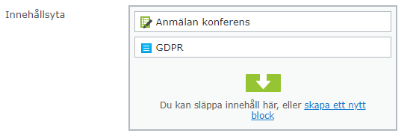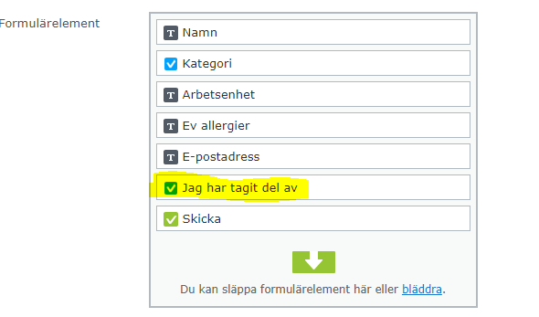

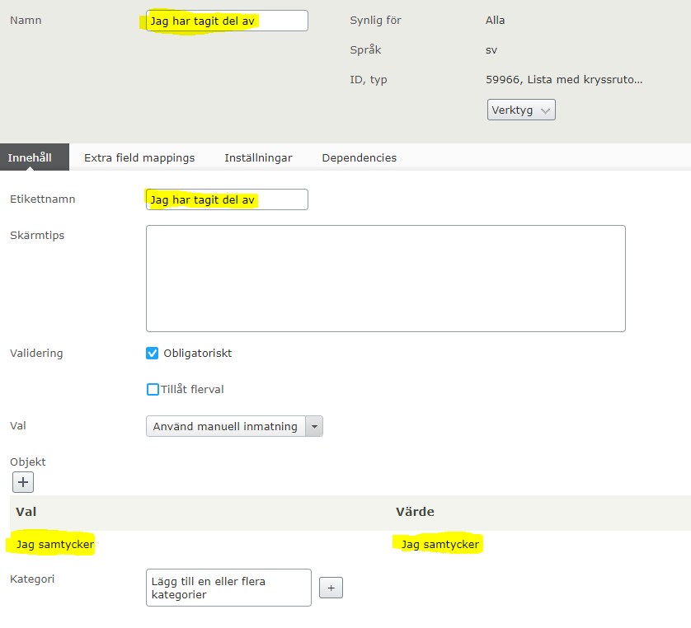

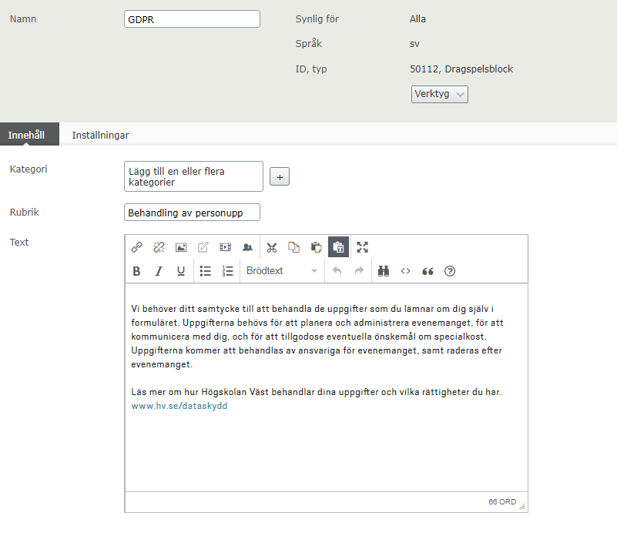

Såhär ser GDPR-informationen ut på sidan

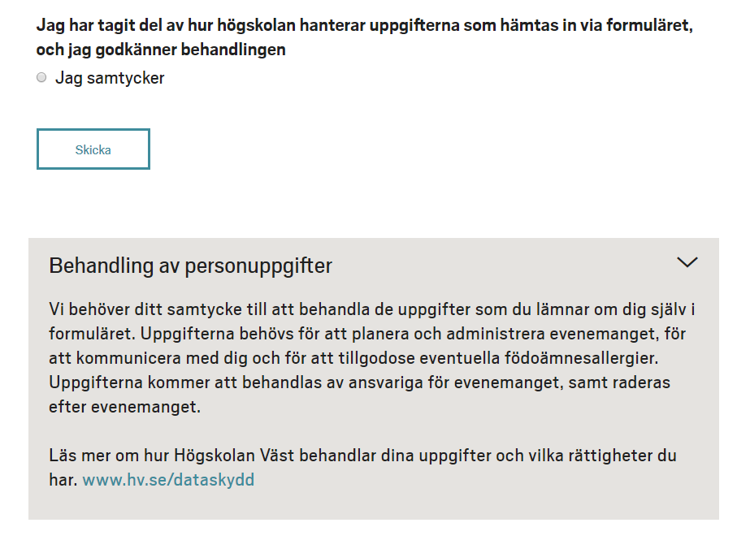

Engelsk version

I have taken part of how the University West handles the personal data that is collected via this form. By clicking “Send” I give my consent to the usage of the data.

I agree

Processing of personal data
The University West needs your consent for handling your personal data collected in this form.The information is needed to plan and manage the event, to communicate with you, and to meet any requests about food. The information will be processed by the event coordinator, and will be deleted after the event.
Read more about how the University West processes your information and your rights. https://www.hv.se/en/gdpr

